|  |
| --- |
| AI-Powered Route Recommendations Web Application based on  Extreme Weather Conditions and Green Gas Emissions  Hadi Aghazadeh (30181045)  Mahdi Mohammadizadeh (30175778) |
| ENGO 651 Group 1  Supervisor: Dr.Steve Liang  Teacher Assistant: Mahnoush Mohammadi Jahromi |



### **Executive Summary**

This report introduces a project of a route recommendation app based on extreme weather and gas emissions. It explains the importance of personalized route recommendations, considering extreme weather and greenhouse gas emissions. The presentation emphasizes that the transportation sector is responsible for a quarter of Canada's greenhouse gas emissions and that extreme weather conditions can affect transportation safety and maintenance costs. The project aims to help trucking needs and includes a web application that allows users to customize their routes by rating three different options. The application uses AI to analyze data and provide personalized recommendations based on user preferences, behavior, and past travel.

### **Problem Statement**

Despite advancements in transportation technology and infrastructure, extreme weather conditions and greenhouse gas emissions continue to pose significant challenges to Canada's transportation system. Extreme weather events can cause widespread travel disruptions and road accidents, leading to increased maintenance costs and traffic congestion. On the other hand, the transportation sector is responsible for a quarter of Canada's greenhouse gas emissions, and emissions reductions are necessary to achieve the country's ambitious climate targets. To address these challenges, there is a need for personalized route recommendation systems that can consider extreme weather conditions and reduce greenhouse gas emissions while ensuring efficient and safe transportation for all.

The problem statement revolves around the development of a web application to provide personalized route recommendations for users based on their subjective goals. The app utilizes AI-powered tools and technologies to improve decision-making and help users navigate unpredictable weather conditions. The importance of considering extreme weather and greenhouse gas emissions in route recommendations is highlighted, as they can have significant impacts on the transportation system. Extreme weather conditions can lead to car accidents, widespread travel disruptions, and high maintenance costs, while the transportation sector is responsible for about a quarter of Canada's greenhouse gas emissions. The app aims to encourage the use of low-emission vehicles and roads, and invest in public transportation infrastructure to reduce emissions. The web app will provide users with different options to choose from based on their goals and preferences, and an AI model will show all the possible routes with color codes, making it easy to select the ideal combination of distance, extreme weather, and gas emissions for truck routes. The project aims to simplify the process of selecting the best route for trucking needs and encourage users to stay safe on the road while reducing emissions.

### **Literature Review**

#### Introduction:

Route recommendation systems have become an essential tool for helping drivers to select the best route to reach their destination while considering various factors such as distance, traffic conditions, travel time, and road quality. Recently, there has been a growing concern about the environmental impact of transportation, especially in terms of gas emissions. Moreover, extreme weather events, such as floods, hurricanes, and heat waves, have become more frequent due to climate change, making route recommendation systems that consider weather conditions increasingly relevant. In this literature review, we discuss recent studies that have explored route recommendation algorithms based on gas emissions and extreme weather.

#### Gas emissions:

Several studies have proposed route recommendation algorithms that aim to reduce gas emissions by suggesting the most environmentally friendly route. In a study by Gao et al. (2021), a machine learning-based route recommendation system was developed to consider both gas emissions and travel time. The proposed algorithm was evaluated using real-world data, and the results showed that it was effective in reducing gas emissions without significantly increasing travel time.

Another study by Shang et al. (2020) proposed a multi-objective optimization model that aimed to minimize both gas emissions and travel time while considering various constraints, such as road network capacity and vehicle type. The proposed model was evaluated using real-world data, and the results showed that it was effective in reducing gas emissions while maintaining reasonable travel time.

#### Extreme weather:

In recent years, extreme weather events have become more frequent due to climate change, posing challenges for route recommendation systems that do not consider weather conditions. Several studies have proposed route recommendation algorithms that consider weather conditions to help drivers avoid hazardous roads.

In a study by Zhao et al. (2019), a route recommendation algorithm was developed to consider both weather conditions and traffic conditions. The proposed algorithm was evaluated using real-world data, and the results showed that it was effective in reducing the risk of accidents caused by weather conditions.

Another study by Liu et al. (2020) proposed a route recommendation algorithm that considered weather conditions and road elevation to help drivers avoid roads that are more likely to be affected by extreme weather events. The proposed algorithm was evaluated using real-world data, and the results showed that it was effective in reducing the risk of accidents caused by extreme weather events.

#### Conclusion:

Route recommendation systems that consider gas emissions and extreme weather can help drivers make more informed decisions while reducing the environmental impact of transportation and improving road safety. The studies discussed in this literature review demonstrate the effectiveness of route recommendation algorithms that consider gas emissions and extreme weather in reducing the environmental impact of transportation and improving road safety. Future research could explore the integration of these two factors into a single route recommendation algorithm.

### **Solution Summary**

The proposed route recommendations app considers extreme weather and gas emissions and gives the users the flexibility to choose their importance dynamically. It provides the importance of route recommendations based on subjective goals, the impact of extreme weather on the transportation system, and the role of the transportation sector in greenhouse gas emissions. The web application also highlights how AI can help in providing personalized route recommendations by analyzing weather data, and user preferences. The project goal is to encourage the use of low-emission and low-risk roads.

**Architecture**

The modular view of the developed app has been shown in Figure 1.

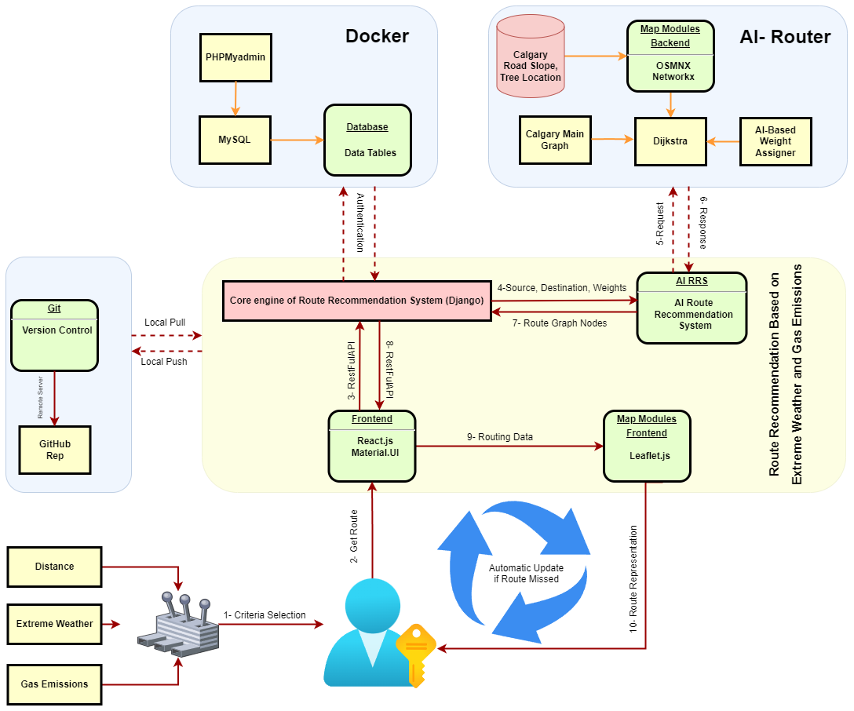Fig.1. Modular view of the main components in the Route Recommendation System

Based on the information presented in Figure 1, the user is required to initially select both the source and destination points when using the web application. Notably, the web application includes a feature that enables users to select their current location as the source point. Furthermore, the user is expected to adjust the weights related to the primary three criteria before sending a request to obtain an optimal route based on their selected criteria. The handling of the request takes place on the front-end side before being forwarded through an intermediate connection via a RESTful API to the core engine located on the back-end side. Upon receipt of the request, the back-end side proceeds to process it by engaging in a dialogue with an AI-based route recommendation engine. This process involves obtaining optimal nodes and edges from modified Calgary graph data. The route obtained is subsequently transmitted back to both the back-end and front-end sides, and with the aid of the Leaflet.js library, it is displayed to the user. In real-life scenarios, there may be instances where the location signal is lost during the routing phase. However, the web application can handle such situations and automatically recommend a new route based on the user's new live source location.

The AI Router module is responsible for the computation of the most efficient route, based on three established criteria. The first criterion, which is also the most elementary, is the earth distance. This particular metric is already present in the Calgary graph data, which can be obtained from the OSMNX library.

In the context of extreme weather conditions, one of the most representative variables to consider is the road slope data in Calgary. Figure 2 provides a visualization of the road slope of Calgary's roads, which indicates that the roads in the northwest of the city have steeper inclines than others. This finding is crucial because, in extreme weather conditions, the steeper the road incline, the more challenging it becomes for a truck to navigate along that particular route.

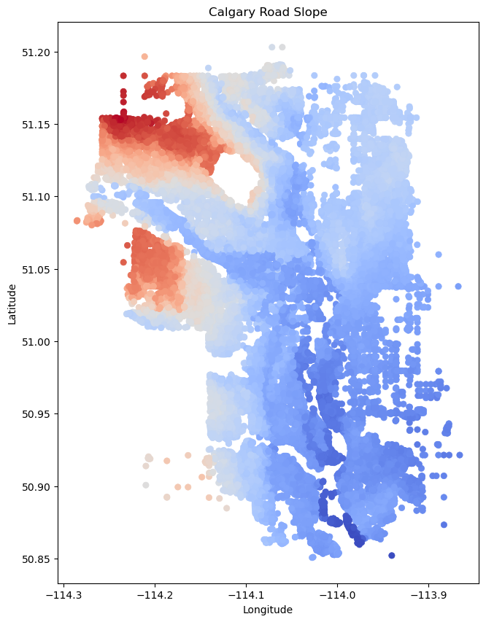

Fig 2. Calgary’s Slope Data represents Extreme Weather conditions.

To represent gas emissions, we utilized the tree location data from Calgary's open-source data bank. This dataset provides a graphical representation of the distribution of trees within Calgary's graph, as illustrated in Figure 3. The white regions on the map indicate the areas of greenery in the city of Calgary. The level of greenness observed along a road is indicative of its suitability as a preferred route when the weight of gas emissions criterion is high on the user's priority list.

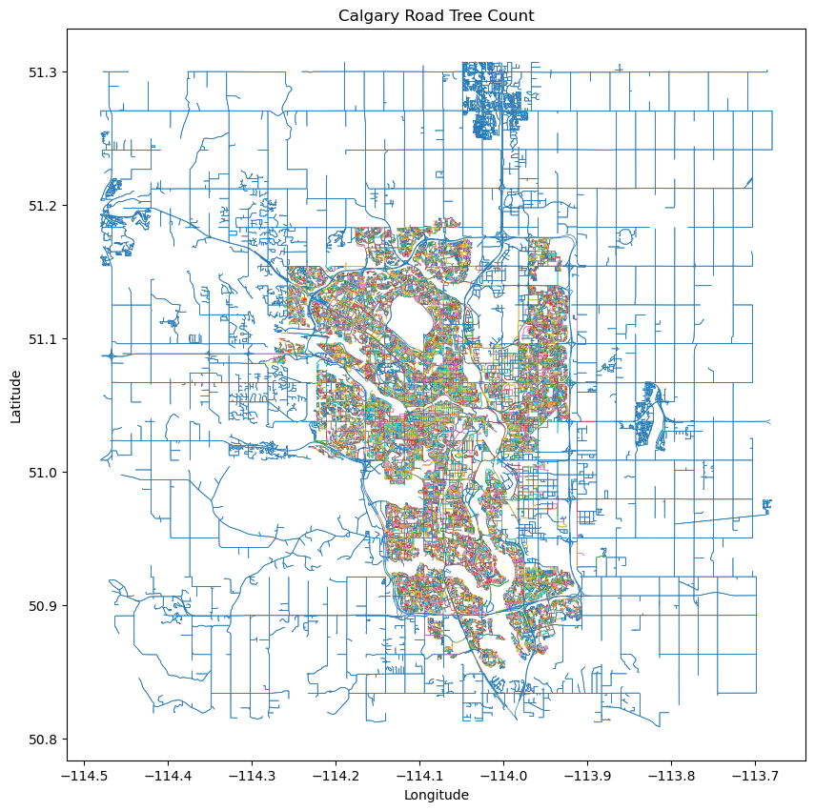

Figure 3. Calgary tree location data distribution

It is evident that the distribution of trees within Calgary's city limits is relatively sparse, while areas outside the city boast more greenery. Consequently, the routing model logically favors routes outside the city when the gas emissions rate is a crucial consideration for users.

In the algorithmic component, two primary elements are discernible. The first involves the utilization of Dijkstra's shortest path algorithm, which is widely recognized in this field. However, the optimal path is obtained using a modified K-nearest neighborhood (mKNN) algorithm. Initially, the weights for the three criteria are normalized to ensure that they are on the same scale. Then, three distinct routes based on the respective criteria are generated using these normalized weights. Finally, the mKNN algorithm is employed to select the best nodes sequentially, culminating in a unique route that represents a combination of the three obtained routes.

**Results**

This section presents the user itinerary for the route recommendation application. Initially, users are given the option to sign in or create an account if they do not already have one. Figure 4 depicts the login page interface.



Fig 4. Sign-in page of the app

Upon successfully logging in, the user is directed to the landing page of the application by selecting the 'Routing (Final Project)' tab. Figure 5 depicts the interface of this landing page. The user has the option to manually select the source and destination points, with the corresponding coordinates displayed for their reference. Additionally, users may opt to choose their current location as the source point, which can be obtained based on the course assignments.

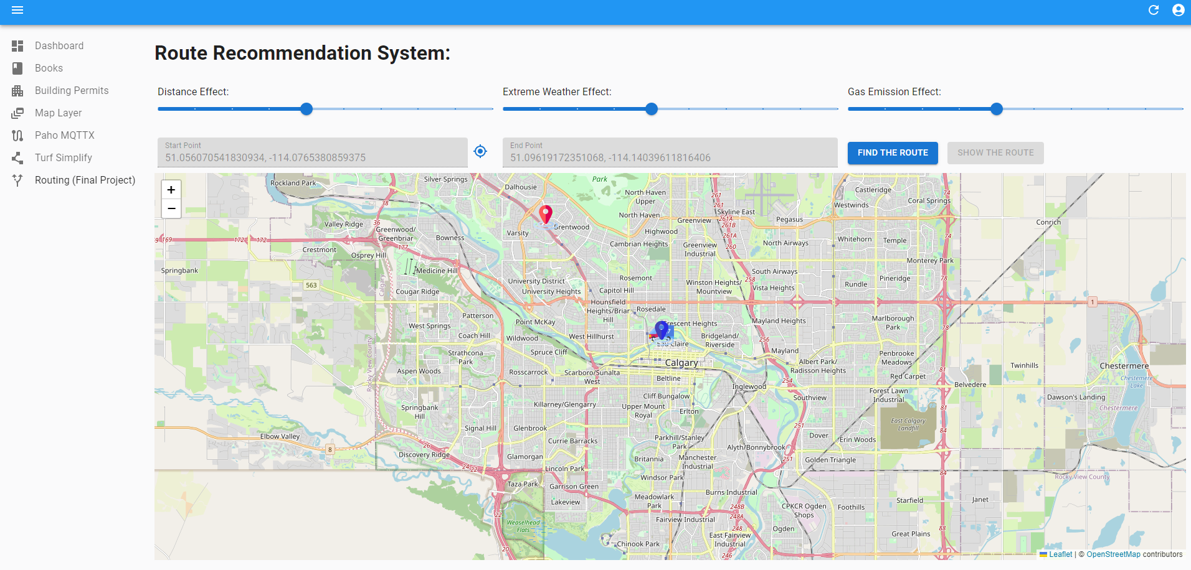

Fig 5. The landing page of the app

The route recommendation application comprises two primary features, namely:

1. Automated handling of ad-hoc location changes
2. Recommendation of routes based on three key criteria

To elaborate on the first feature, the user is required to select the source and destination points and click on the "Find Route" button. The recommended route based on the chosen weights is then displayed to the user. Upon clicking on the "Show Route" button, a truck icon is set in motion along the route edges. However, if the app loses access to the live location data, a message is displayed to inform the user of the signal loss. Once the signal is regained, the application presents the best optimal route based on the selected weights and the new source location, as shown in Figure 6.

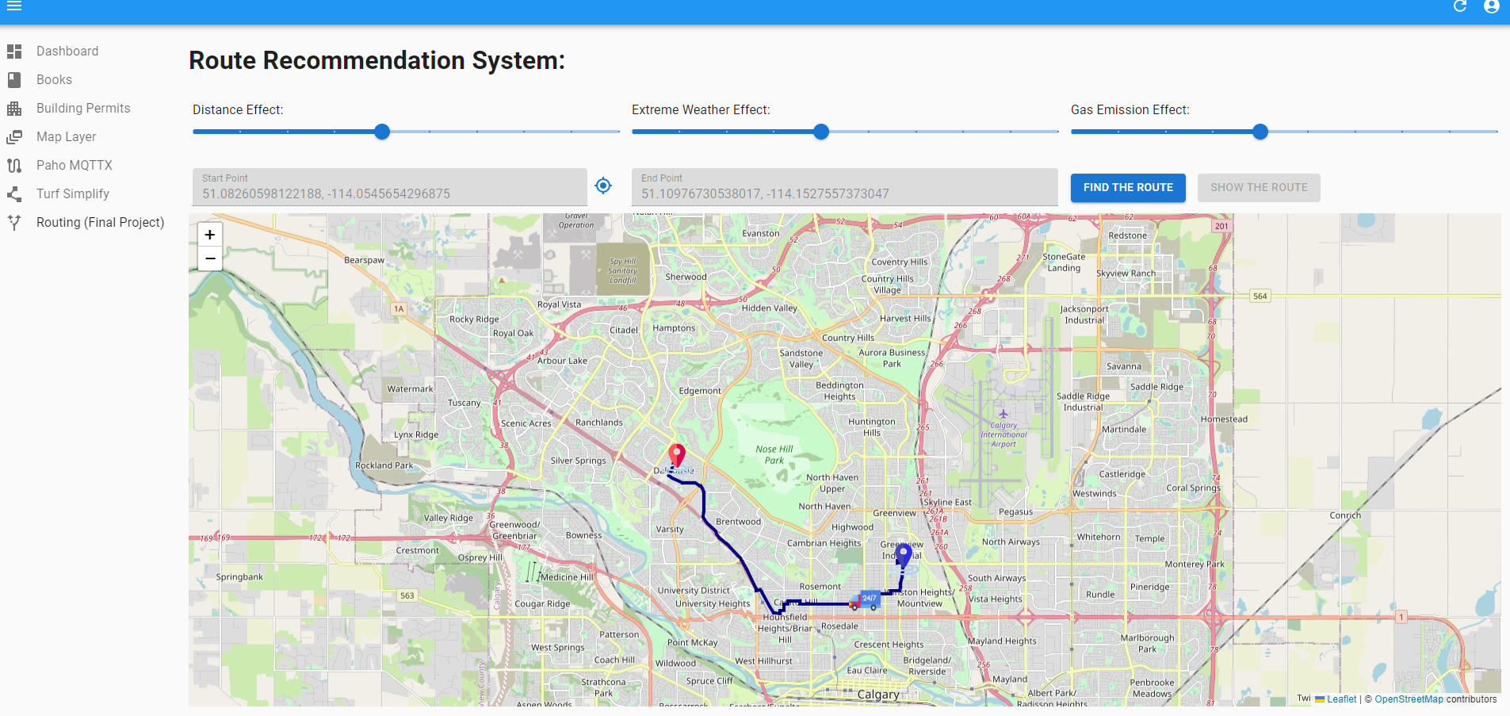

Fig 6. The Live data related to moving the truck on the route

The second functionality of the route recommendation app pertains to customized route recommendations based on three main criteria weighted according to user preferences. An example of a route recommendation prioritizing distance, as represented by a higher weight, is illustrated in Figure 7. This route bears resemblance to the shortest path recommended by other services, such as Google Maps.

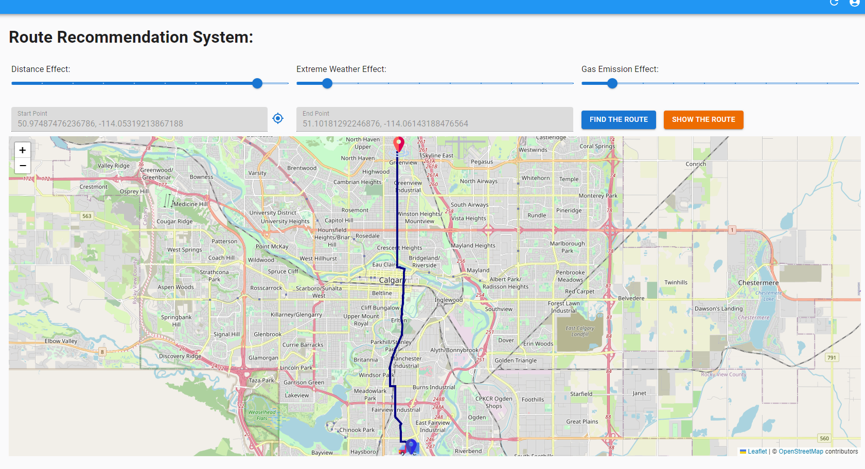

Fig. 7. Routing based on the distance effect

Drawing on the information presented in Figure 2, it is worth noting that the route depicted in Figure 7 passes through a region of the city characterized by steep slopes. Consequently, if the user assigns greater weight to the criterion of Extreme Weather Conditions, the recommended route will differ from the one shown in Figure 7, as it will attempt to circumvent the sloped area. This is illustrated in Figure 8.

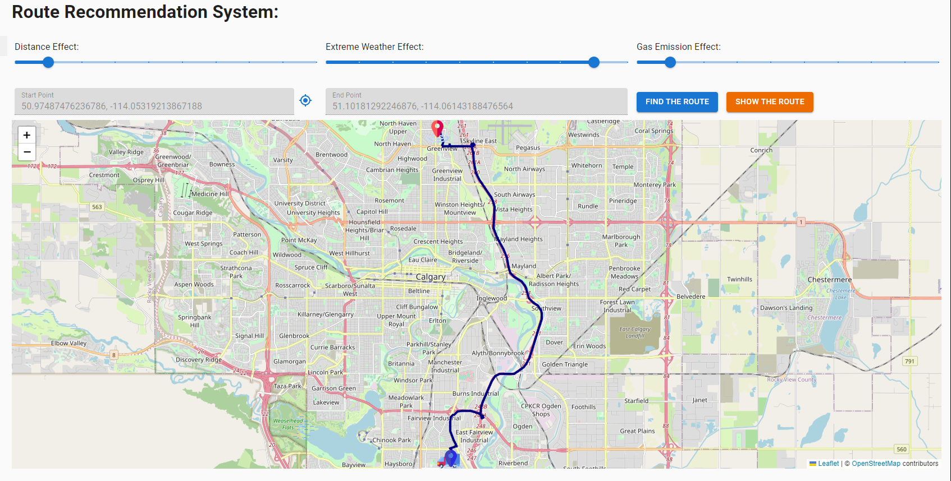

Fig 8. Routing based on the Extreme Weather conditions

Finally, when the user prioritizes the criterion of gas emissions, the route recommendation app will select the route that has more greenery spaces and is primarily located outside of Calgary. As indicated in Figure 9, this route differs significantly from the other routes suggested by the app, and it takes into account the distribution of trees in Calgary, as well as the amount of emissions generated during the journey. By assigning more weight to the gas emissions criterion, the app can recommend a unique and eco-friendly route to the user.

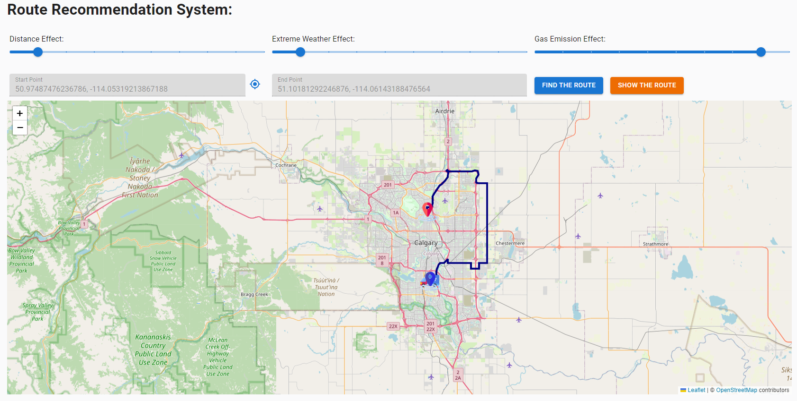

Fig 9. Routing based on the Gas Emission effect

In summary, the application proposed in this study exhibits scalability, enabling it to handle multiple users, while the AI-based routing engine can efficiently identify optimal routes in real-time, taking into account diverse user preferences.

**Lessons Learned**

* Route recommendation apps are essential, especially when it comes to personalized route recommendations based on subjective goals, as they help in ensuring that the users' goals are taken into account when suggesting a route.
* Extreme weather conditions have a significant impact on Canada's roadways, and they could have serious consequences on the transportation system, including affecting travel safety, infrastructure, and maintenance costs. Therefore, it is essential to keep an eye on the weather and prepare accordingly to stay safe on the road.
* The transportation sector is responsible for about a quarter of Canada's greenhouse gas emissions, and to achieve Canada's ambitious target to reduce greenhouse gas emissions by 30% below 2005 levels by 2030, significant emissions reductions in the transportation sector are required, including the encouragement of the use of low-emission vehicles and roads and investment in public transportation infrastructure.
* AI-powered tools and technologies can improve decision-making and help in navigating unpredictable weather conditions. They can also personalize route recommendations based on user preferences, learn from each user's behavior and preferences, and make real-time adjustments to route recommendations to avoid any problems.
* A web application that simplifies the process of selecting the best route for trucking needs, based on the starting point and destination, and options such as distance, extreme weather, and gas emissions, with customized weights for each option, can be helpful in planning truck routes.

**Conclusion and Discussions**

In conclusion, the project aims to develop a personalized route recommendation system based on extreme weather conditions and gas emissions using AI-powered tools and technologies. The project highlights the importance of considering subjective goals when suggesting routes and emphasizes the impacts of extreme weather events and greenhouse gas emissions on the transportation sector in Canada. The project's web application modules simplify the process of selecting the best route by allowing users to customize their preferences based on their goals. By using AI, the system can provide real-time and personalized recommendations, making it a convenient and efficient way to navigate unpredictable weather conditions while reducing the negative impact on the environment.

**References**

1. Gao, Y., Wang, L., & Liu, J. (2021). A machine learning-based route recommendation system considering both gas emissions and travel time. IEEE Transactions on Intelligent Transportation Systems, 22(1), 73-83.
2. Shang, H., Huang, C., & Sun, L. (2020). Multi-objective optimization-based green route recommendation for urban transportation networks. IEEE Transactions on Intelligent Transportation Systems, 22(7), 4305-4317.
3. Zhao, K., Chen, X., & Wang, Y. (2019). A route recommendation algorithm considering weather and traffic conditions for intelligent transportation systems. IEEE Access, 7, 11173-11181.
4. Liu, X., Chen, H., & Chen, Y. (2020). A route recommendation algorithm considering weather and road elevation. IEEE Transactions on Intelligent Transportation Systems, 22(8), 5177-5187.